Granger predictability: AUDUSD and USDJPY
Method 13 / daily log returns / p=1 and p=5 / Alpari D1 full available history

Study setup
Logical pair: AUDUSD , USDJPY
Broker symbols: AUDUSD_i , USDJPY_i
Snapshot: 2026-11-03_majors_alpari_D1
Timeframe: D1
Matched return window: 1999-01-05 to 2026-11-02 (UTC bar dates)
Matched return count n: 7199
Dropped unfinished last bar dated 2026-11-03 UTC after a tick-volume check against the prior complete day.
Lag orders pre-specified: p=1 and p=5; both directions
Headline: p=5 joint F test in both directions
Complete matched rows (Excel): AUDUSD-USDJPY_Granger_D1.xlsx
Complete matched rows (HTML table): AUDUSD-USDJPY_Granger_D1_data.html

Method carried forward
Granger predictability asks whether lagged X helps explain Y beyond lags of Y alone on matched daily log returns of close, ln(close_t / close_t-1). Quotes are not inverted. For lag order p, the unrestricted model is y_t on an intercept, y_{t-1}..y_{t-p}, and x_{t-1}..x_{t-p}. The restricted model drops the x lags. The test is an F comparison of residual sums of squares via OLS (numpy.linalg.lstsq) and scipy.stats.f. Orders p=1 and p=5 are pre-specified; both directions are tested. The headline is the p=5 joint test in both directions. p=1 is reported beside it because the guide formula is the one-lag regression. Rejecting H0 is statistical predictability in mean in this sample; it is not economic causation and not a trading signal. There are 56 directed tests at p=5 across the 28 pairs.

Results
direction | p_lags | n | f_stat | p_value | b | df1 | df2
AUDUSD_to_USDJPY | 1 | 7198 | 18.327177 | 1.884e-05 | -0.04159952 | 1 | 7195
AUDUSD_to_USDJPY | 5 | 7194 | 4.0516253 | 0.00112954 | nan | 5 | 7183
USDJPY_to_AUDUSD | 1 | 7198 | 3.0525366 | 0.08065382 | 0.02511426 | 1 | 7195
USDJPY_to_AUDUSD | 5 | 7194 | 1.0665538 | 0.37673039 | nan | 5 | 7183

Conclusion
Headline p=5 joint tests for AUDUSD and USDJPY: AUDUSD->USDJPY F=4.0516 (p=0.00112954); USDJPY->AUDUSD F=1.0666 (p=0.37673); usable rows n=7194. One-lag slopes: b_AUDUSD->USDJPY=-0.0416 (F=18.3272, p=1.8845e-05); b_USDJPY->AUDUSD=0.0251 (F=3.0525, p=0.0806538). Rejecting H0 is in-sample mean predictability, not economic cause and not a trading signal.

Charts
Daily closes

Daily log returns

Granger F statistics
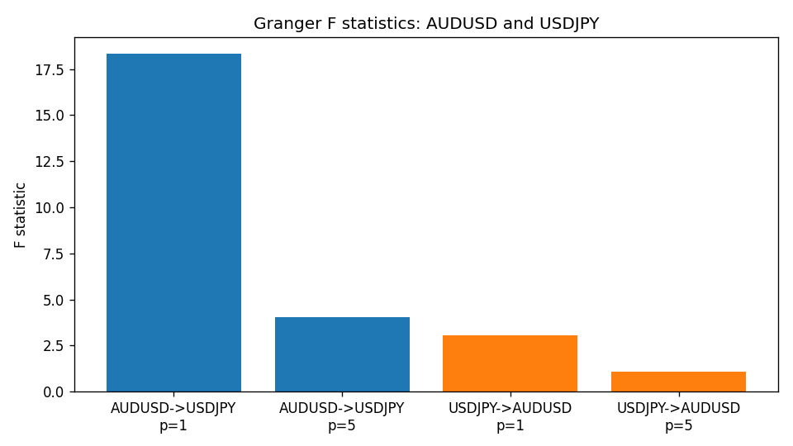

Data report
Every matched row is stored in the sibling Excel workbook named AUDUSD-USDJPY_Granger_D1.xlsx (sheet matched_rows). The results sheet holds the four F tests. Embedding all rows as a Word table is impractical; the Word file holds column summaries and the first and last 15 rows.
Columns: time, AUDUSD_open, USDJPY_open, AUDUSD_high, USDJPY_high, AUDUSD_low, USDJPY_low, AUDUSD_close, USDJPY_close, AUDUSD_tick_volume, USDJPY_tick_volume, AUDUSD_spread, USDJPY_spread, AUDUSD_real_volume, USDJPY_real_volume, AUDUSD_log_return, USDJPY_log_return
Column summaries (matched calculation rows)
column | count | mean | std | min | 25% | 50% | 75% | max
AUDUSD_open | 7199 | 0.75196998 | 0.13527571 | 0.4785 | 0.661035 | 0.73142 | 0.809135 | 1.10284
USDJPY_open | 7199 | 113.81114 | 19.206896 | 75.693 | 104.4285 | 110.984 | 120.6925 | 163.824
AUDUSD_high | 7199 | 0.75602148 | 0.13583632 | 0.4878 | 0.6647 | 0.7349 | 0.815325 | 1.10795
USDJPY_high | 7199 | 114.30872 | 19.268446 | 76.001 | 104.881 | 111.442 | 121.26 | 163.978
AUDUSD_low | 7199 | 0.7479145 | 0.13459018 | 0.4775 | 0.6577 | 0.72758 | 0.80425 | 1.0975
USDJPY_low | 7199 | 113.28779 | 19.134887 | 75.402 | 103.89 | 110.53 | 120.17 | 163.628
AUDUSD_close | 7199 | 0.75202255 | 0.13525884 | 0.4786 | 0.661195 | 0.73175 | 0.809235 | 1.10169
USDJPY_close | 7199 | 113.824 | 19.222288 | 75.811 | 104.42 | 111.025 | 120.687 | 163.851
AUDUSD_tick_volume | 7199 | 77366.826 | 138149.99 | 109 | 5440 | 43349 | 71344.5 | 1234623
USDJPY_tick_volume | 7199 | 106151.62 | 179316.41 | 197 | 9927 | 53098 | 92761 | 1803508
AUDUSD_spread | 7199 | 30.814558 | 16.886804 | 0 | 13 | 30 | 50 | 50
USDJPY_spread | 7199 | 20.321434 | 17.631726 | 0 | 6 | 11 | 30 | 50
AUDUSD_real_volume | 7199 | 5.2435469e+09 | 1.2539788e+11 | 0 | 0 | 0 | 0 | 3.811512e+12
USDJPY_real_volume | 7199 | 3.470603e+10 | 1.6078743e+11 | 0 | 0 | 0 | 0 | 3.8834203e+12
AUDUSD_log_return | 7199 | 2.78e-05 | 0.00754502 | -0.08602525 | -0.00385397 | 0.00028846 | 0.00415332 | 0.0806166
USDJPY_log_return | 7199 | 4.761e-05 | 0.00620532 | -0.03908203 | -0.00320306 | 0.00011368 | 0.00340781 | 0.05184024
First 15 matched rows (selected columns)
time | AUDUSD_close | USDJPY_close | AUDUSD_log_return | USDJPY_log_return
1999-01-05 | 0.6215 | 111.92 | -0.00080418179 | -0.00017868311
1999-01-06 | 0.6289 | 112.77 | 0.011836351 | 0.0075660159
1999-01-07 | 0.6345 | 111.33 | 0.0088650256 | -0.012851583
1999-01-08 | 0.6347 | 110.8 | 0.00031515916 | -0.0047719894
1999-01-11 | 0.6393 | 109.02 | 0.0072213815 | -0.016195423
1999-01-12 | 0.6362 | 112.6 | -0.0048608485 | 0.032310364
1999-01-13 | 0.6312 | 113.52 | -0.0078902098 | 0.0081373171
1999-01-14 | 0.6295 | 113.52 | -0.002696916 | 0
1999-01-15 | 0.634 | 114.15 | 0.007123101 | 0.0055343401
1999-01-18 | 0.6346 | 114.16 | 0.00094592471 | 8.7600193e-05
1999-01-19 | 0.6392 | 113.52 | 0.0072225153 | -0.0056219403
1999-01-20 | 0.64 | 112.91 | 0.0012507819 | -0.0053879917
1999-01-21 | 0.6405 | 113.87 | 0.00078094498 | 0.0084664056
1999-01-22 | 0.6327 | 114.56 | -0.012252745 | 0.0060412564
1999-01-25 | 0.6302 | 113.72 | -0.0039591468 | -0.0073594164
Last 15 matched rows (selected columns)
time | AUDUSD_close | USDJPY_close | AUDUSD_log_return | USDJPY_log_return
2026-10-13 | 0.69821 | 158.305 | 0.0035007712 | -0.0018932826
2026-10-14 | 0.69715 | 158.317 | -0.0015193215 | 7.5800166e-05
2026-10-15 | 0.69191 | 158.024 | -0.0075447063 | -0.0018524319
2026-10-16 | 0.69426 | 157.964 | 0.0033906408 | -0.00037976126
2026-10-19 | 0.6978 | 158.517 | 0.0050859986 | 0.0034946841
2026-10-20 | 0.70022 | 158.16 | 0.0034620426 | -0.0022546642
2026-10-21 | 0.70275 | 158.108 | 0.0036066384 | -0.00032883504
2026-10-22 | 0.70186 | 156.755 | -0.0012672558 | -0.0085942669
2026-10-23 | 0.70353 | 156.81 | 0.0023765656 | 0.00035080446
2026-10-26 | 0.70128 | 157.458 | -0.0032032829 | 0.0041238746
2026-10-27 | 0.70245 | 157.894 | 0.0016669876 | 0.0027651658
2026-10-28 | 0.70533 | 157.743 | 0.0040915541 | -0.00095679538
2026-10-29 | 0.70245 | 157.683 | -0.0040915541 | -0.00038043789
2026-10-30 | 0.70316 | 157.516 | 0.0010102376 | -0.0010596481
2026-11-02 | 0.69971 | 157.933 | -0.0049184984 | 0.0026438521

